Verify Check  Cab  Cleanliness  Seat condition OK  Operator restraint provided  Instruments operational & labeled  Levers / controls operational  Pedals in good condition  ROPS to AS 2294  Windows / wipers / washers  Rear view mirrors  Operator instruction  (available on plant)  Warning devices  Verify Check  Horn  Reversing alarm  Verify Check  Warning signs (in cabin)  SEAT BELTS MUST BE WORN | Supplier verification & Plant details
 | Plant owner:
 | Address:
 | City/Suburb:
Verify Check  Exhaust  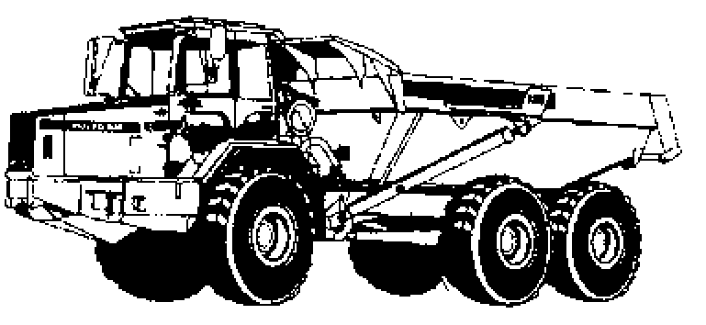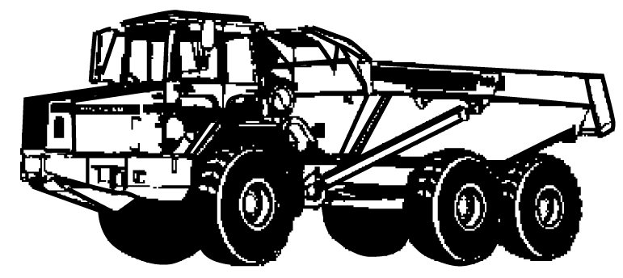 | Phone:
 | Plant make:
 | Plant model:
 | Serial no.:
 | Signature:
 | Date:
 | Statement of operator competence required
Verify Check  Tyres  Wheels  Brakes  Park brake  Verify Check  Rams  Hoses  Connections  (check for excessive wear, leaks and creep)  Hydraulics |  Plant to conform to manufacturer’s specifications and Plant Regulations.   Plant operator is to provide daily checksheets to WDA on a weekly basis   Where applicable, Personal Protective Equipment must be worn.   Plant Log Book detailing service history in accordance with Manufacturer’s specifications should be written legibly in English.   Contractor must produce proof of competence of operator, e.g., Certificate of Competence, Licence, detailed Log Book.
Verify Check  Handrails  Steps  Verify Check  (signs on both sides of vehicle)  KEEP CLEAR | WDA use only
 | Note: Sign only when all items have been checked
 | Plant check by:
Instructions:  Verify Box to be ticked by Owner / Supplier / Operator prior to arrival onsite.  Check Box to be ticked after visual inspection by WDA | Position:
Note : Plant to be registered if used on public roads | Date: |  | / /

